**Term project Proposal**

**Project Description**

This project is a side scroller game called Go Disney Princess.

**Background story**

The world is fighting a scary virus that caused a lot of death. To save the world, three brave Disney princesses formed a squad to get the antidote in a castle guarded by a ferocious dragon. On the adventurous way to the castle, they have to fight different enemies and overcome many obstacles; but they work unitedly as a team using the different abilities that they have, and finally reach the destination and beat the dragon.

**How it works**

In the game, players can play the roles of three Disney princesses: Mulan, Elsa, and Jasmine. Each princess has her own actions: Mulan can attack the enemies with the sword, Elsa can freeze the enemies with her magic, and Jasmine can fly over the obstacles with her magic carpet. All of the princesses can walk, run and jump, and shoot balls to enemies. Players can switch characters at any point, they have to strategically decide which princess to choose given the different challenges that they encounter. The worlds are full of enemies and platforms, and obstacles. The players have three lives, they can collect lives along the way as makeups for the lost ones, they will lose the game if they lose all of their lives. At the end of the game when they are facing the Axe enemy, the different powers will combine as one, so players can use the different superpowers without switching characters.

**Competitive Analysis**

I explored some side scroller games online including Super Mario, DONKEY KONG COUNTRY Number 10, and also looked at some 112 projects that used pygame.

Similarity: My game will involve some basic features in traditional platformers and side scroller games such as jumping between platformers, collecting rewards, and fighting enemies.

Difference: My game has a special theme about Disney princesses that no one has done before and the background story is interesting. There is also a special feature, which is that players can switch to monitor different Disney princesses that have different powers at any time during the game. What’s more, unlike most games that have different modes, this game has only one mode and the difficulty level will increase as the player moves right.

**Structural Plan**

My game will include three levels. As the player moves right, the game will become more and more difficult.

I will use three files to organize the code and link them together by importing one from another.

1. **Settings.py** is used to store fundamental information such as width and height of the window, width and height of the objects, colors, , images, etc.
2. **main.py** that contains the main game code

Game Class

# initialize the game

new()

run()

# update the screen

update()

# loop through all the events

event()

# draw the sprites

draw()

1. **Sprites.py** that contains all the sprites classes

Princesses

Upper class: Princess

Inherited class 1: Mulan

Inherited class 2: Elsa

Inherited class 3: Jasmine

Enemies

Upper class: Enemy

Inherited class 1: QuickEnemy

Inherited class 2: FlyingEnemy

Inherited class 3: Dragon

Object

Platform

Award

Sword

Carpet

Ice

Fireball

Ball

Axe

I will also create a folder to put all the images, and a folder to put all the sound files.

**Algorithmic Plan**

Level 1: Jumping, collecting rewards, and fighting enemies, moving forward, platforms will be shorter and the player will die if fall down.

Level 2: Flying enemies that will attack the player with fire, and can dodge attack

Boss: Fiery dragon, can chase the player, can fly, can heal itself, can shoot fireball.

More complex parts:

Boss finding the shortest path to reach the player

Boss predicting player movement

Boss shooting fireball to the player in different angles

**Timeline Plan**

|  |  |  |  |  |  |
| --- | --- | --- | --- | --- | --- |
| Time | CP4/TP1 April 16 | CP5  April 20 | CP6/TP2  April 23 | CP7  April 27 | TP3  April 29 |
| Due | Jumping  Collecting  Fighting  Switching roles | Side scrolling  Include All the levels | Finalize all the levels | Add sounds  More Intelligent Game AI | Video Demo  Final product |

**Version Control Plan**

I will save all my work for each checkpoint into google drive.

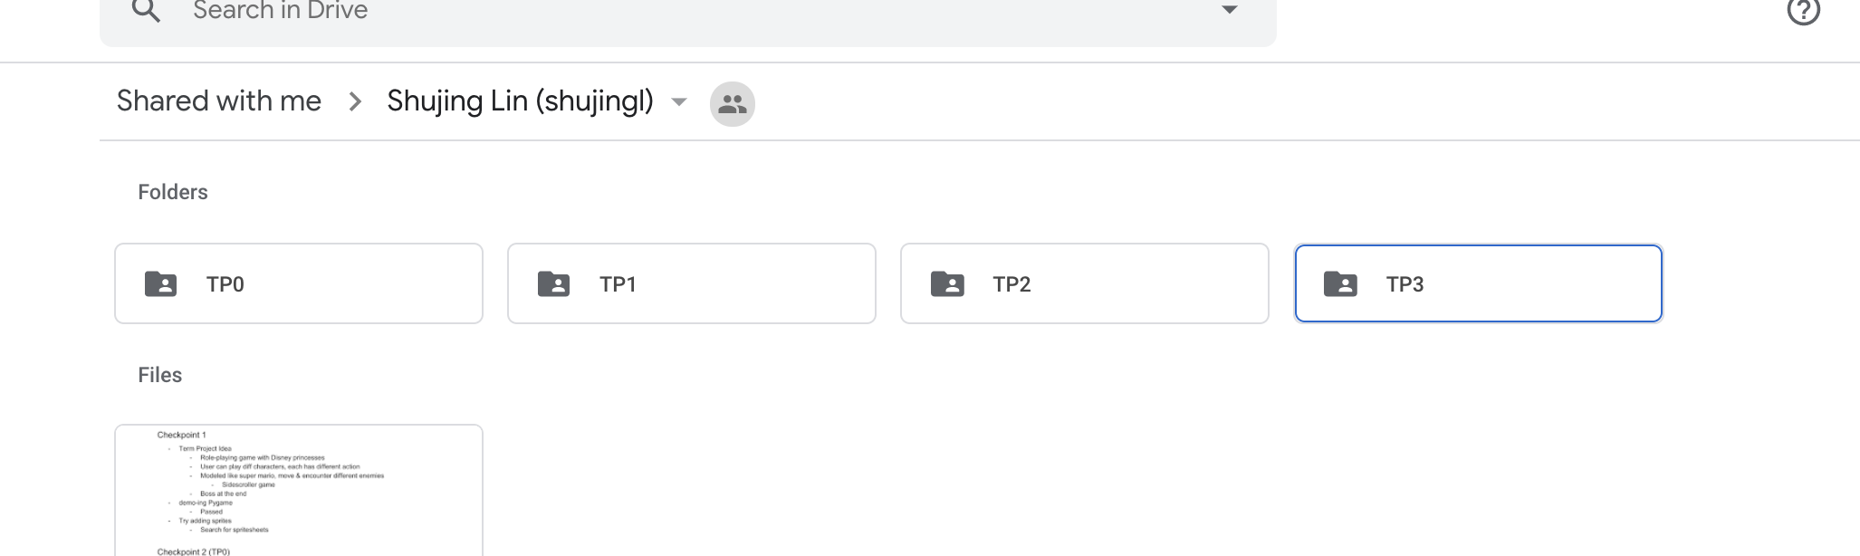

**Storyboardx4**

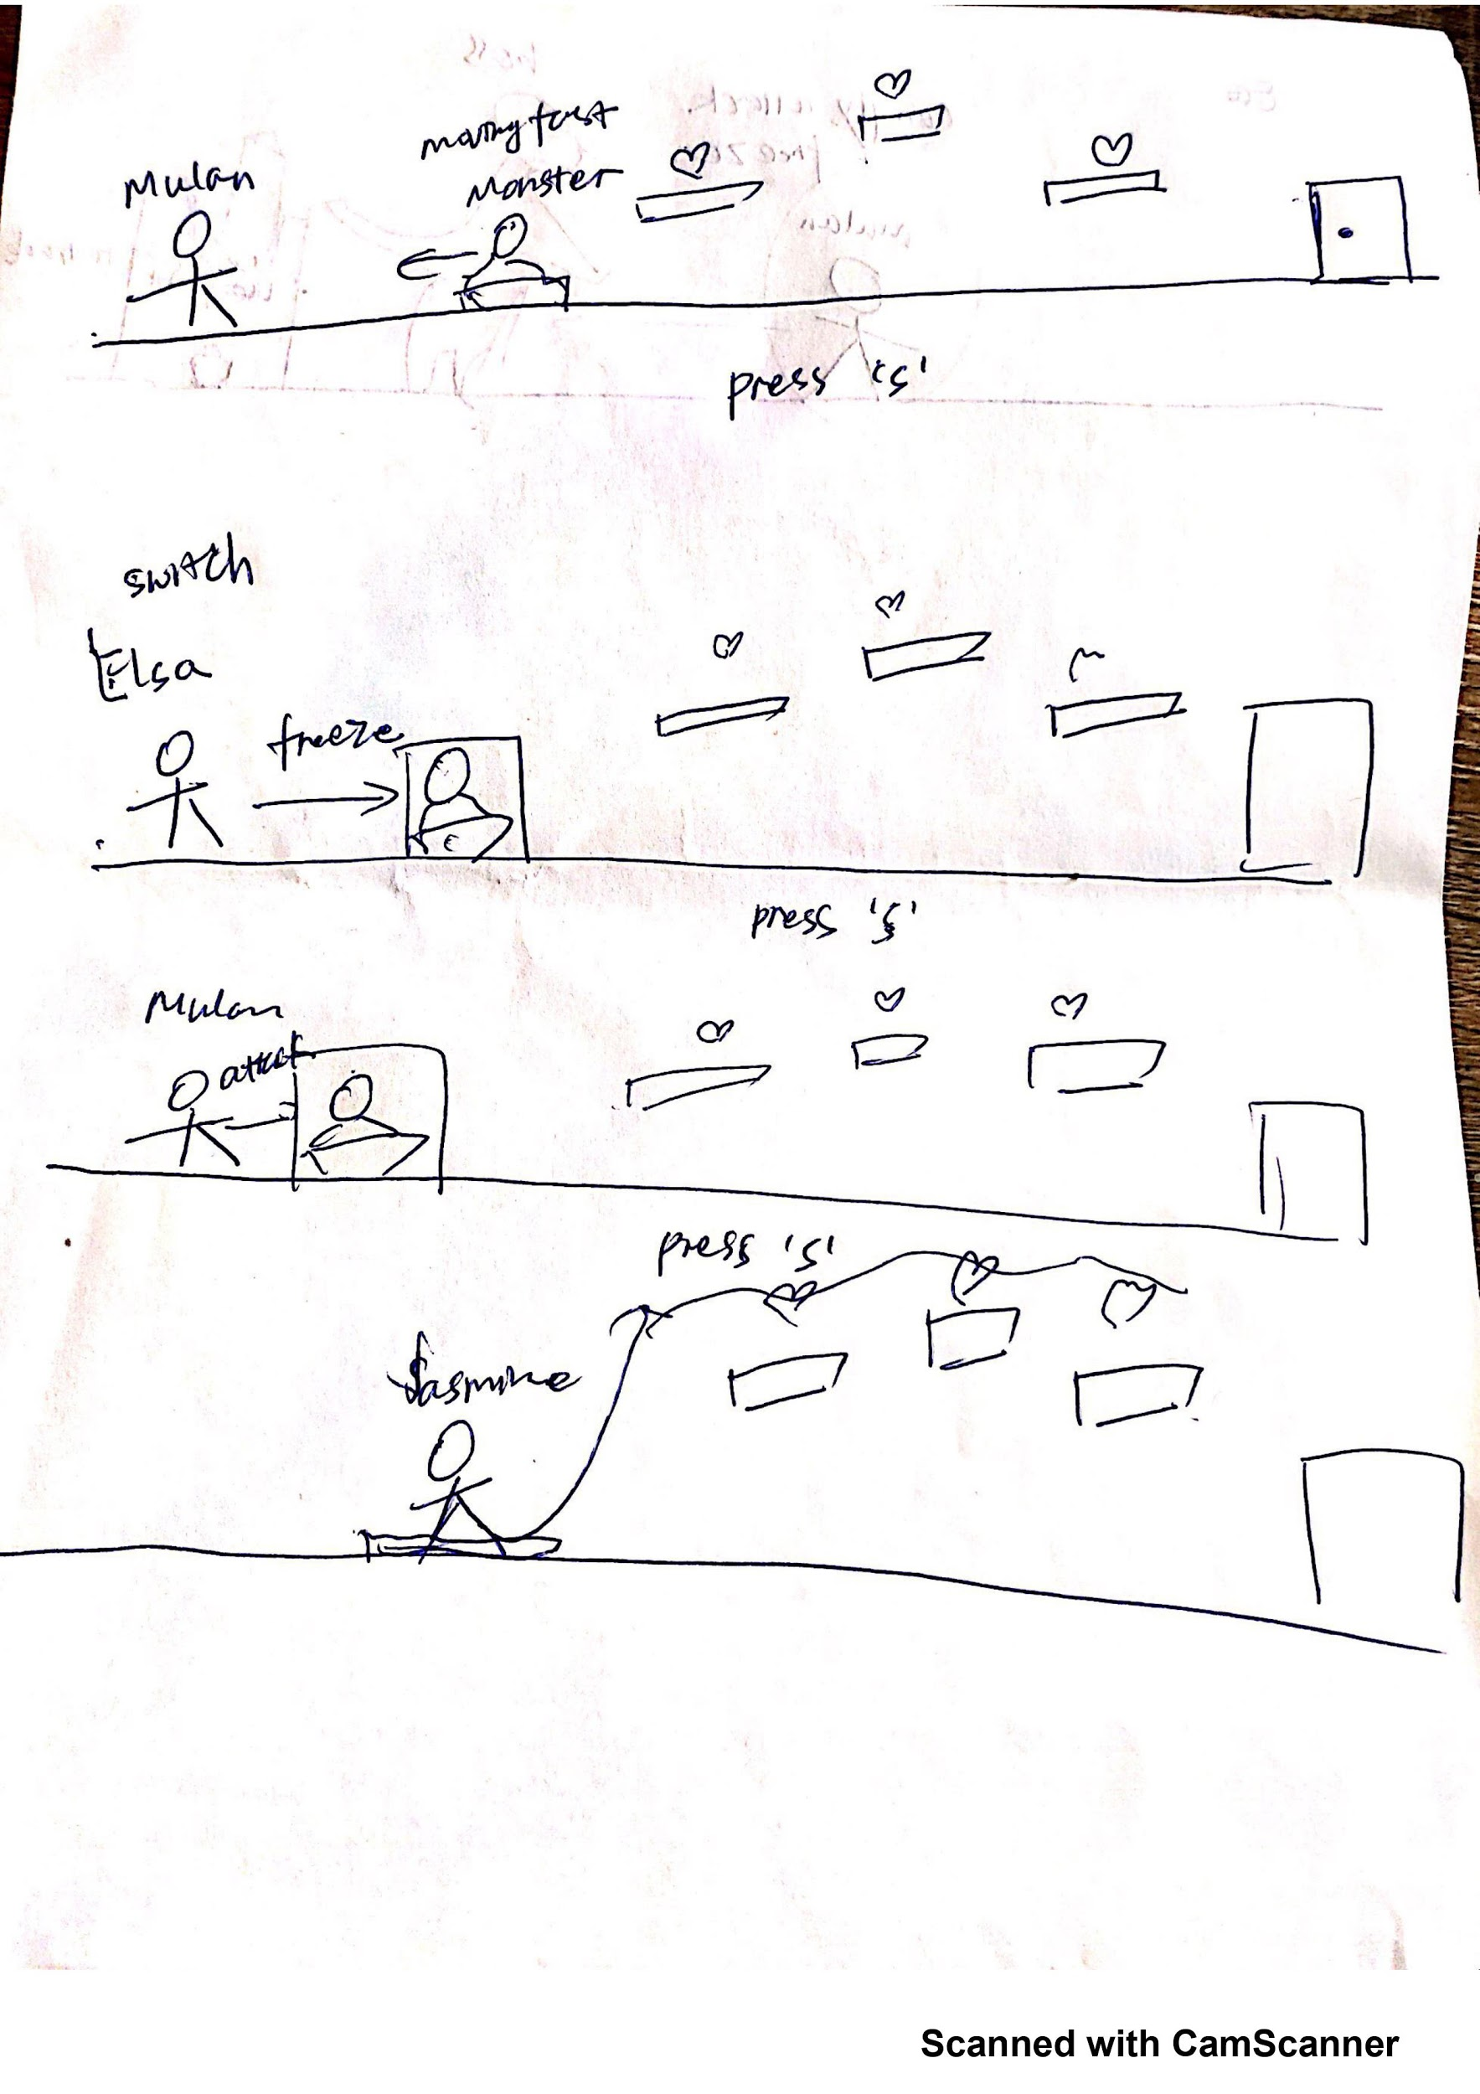

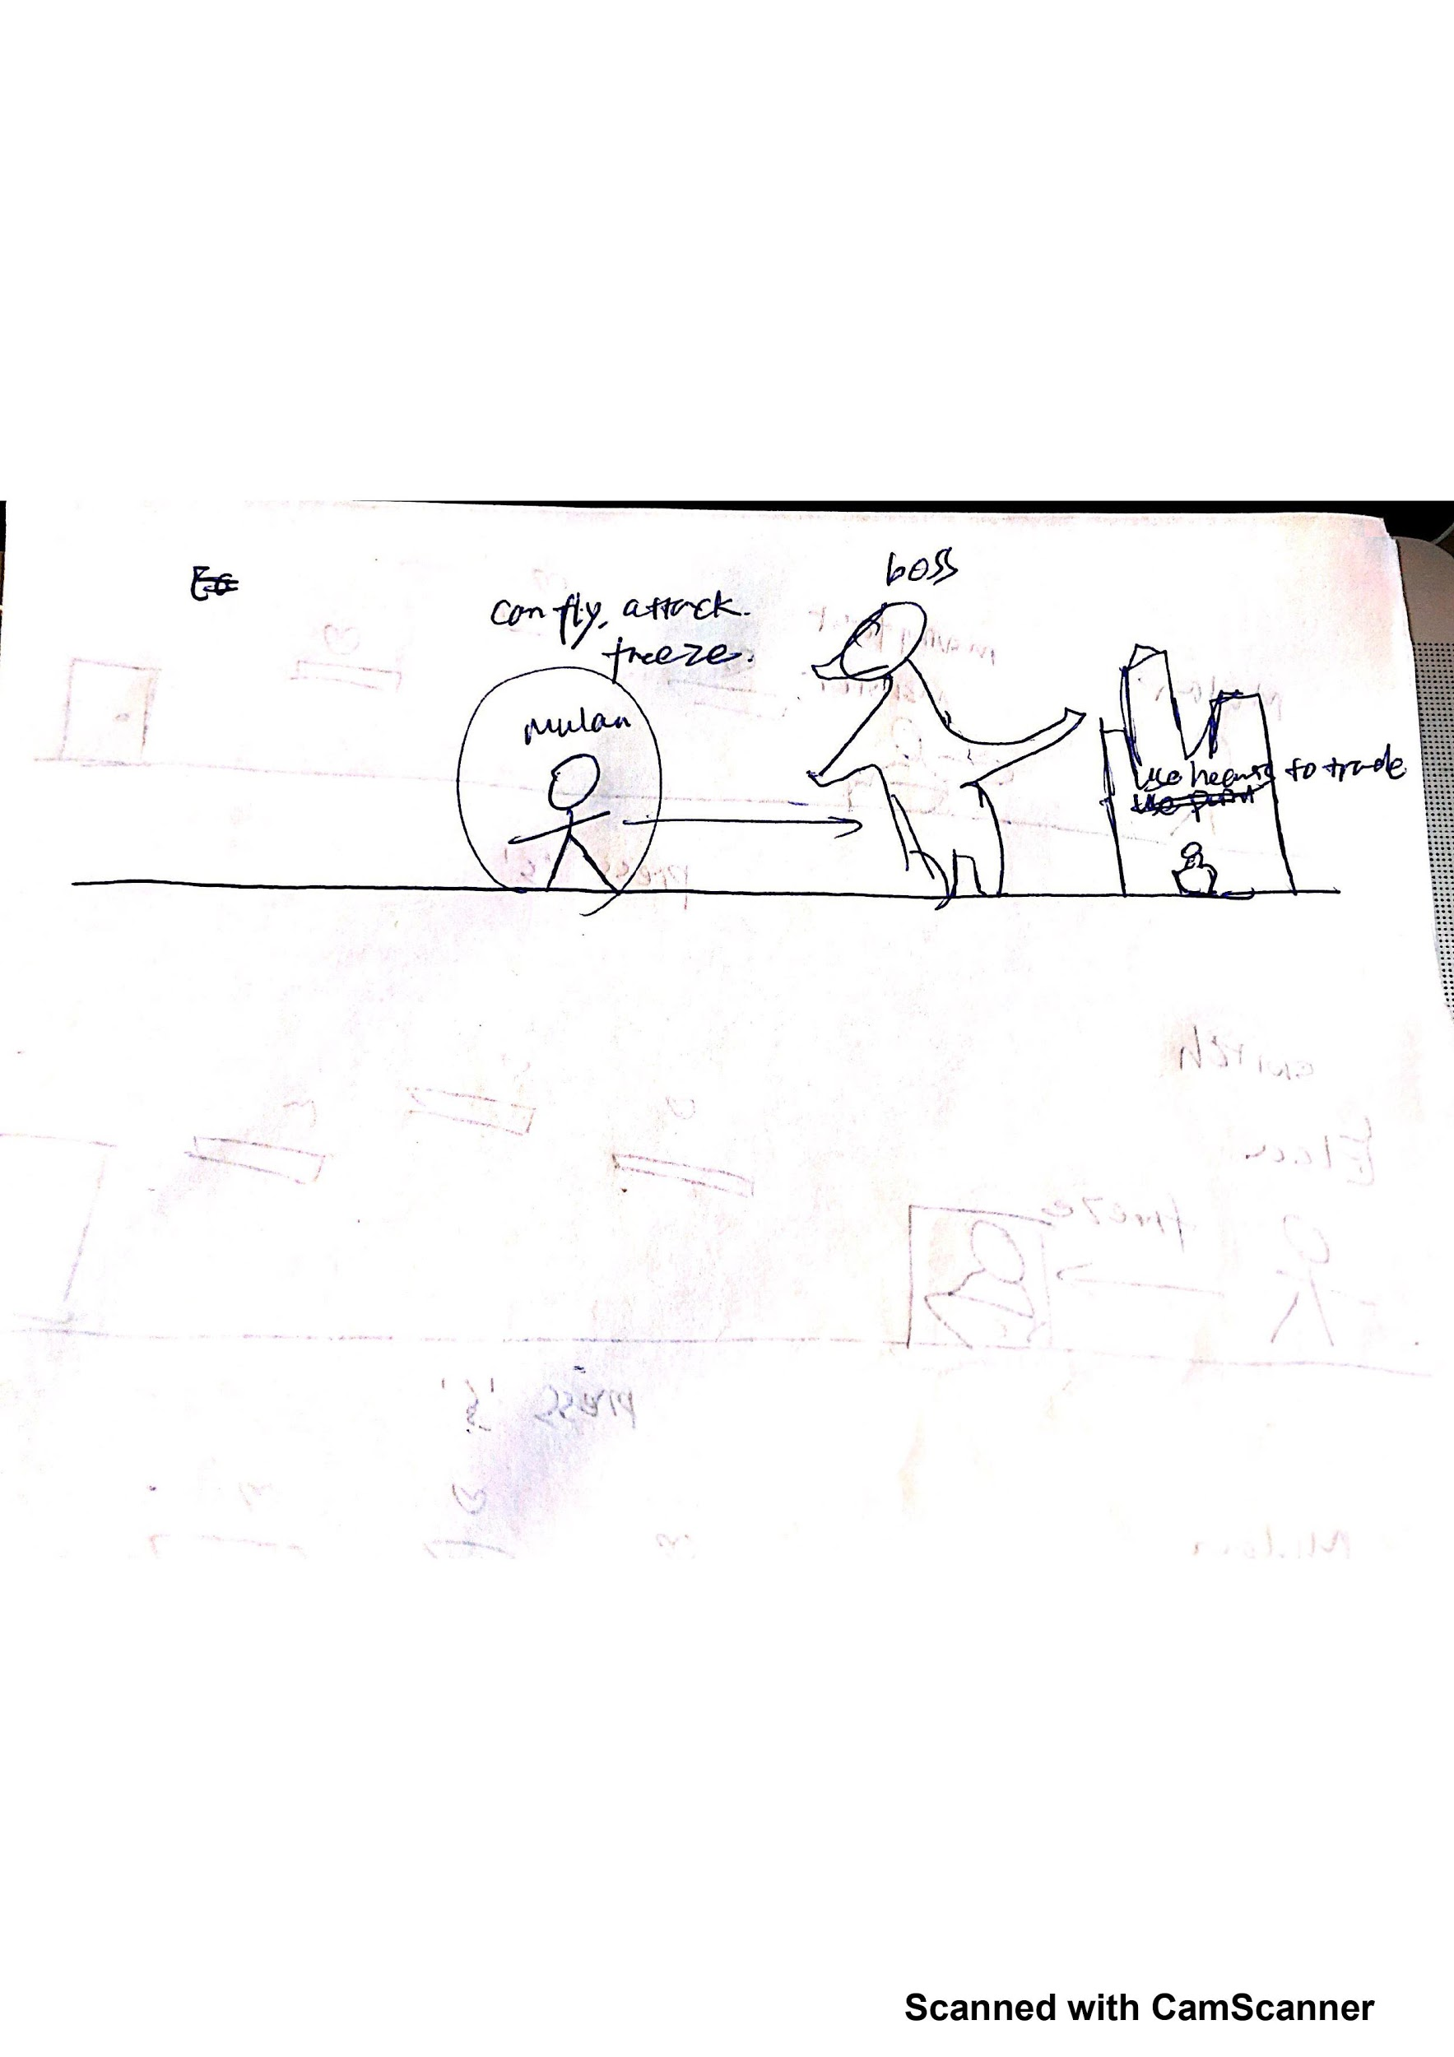

**TP3 Update**

**Version Control Plan**

I decided to use Github to synchronize my code as I make progress.

<https://github.com/shujingl-2020/go_disney_princess>

**Structural Plan**

Level 1: Jumping, collecting rewards, bypassing obstacles, and fighting soldier enemies. Player has to kill 10 enemies to reach the next level.

Level 2: Flying enemies that will attack the player with fire and dodge attack. Kill 10 flying enemies and the dragon boss to reach the next level.

Level 3: Moving platforms with no floor. The enemies can find the shortest path. The Axe Enemy can jump between the platforms to chase the player. Beat the final boss (Axe Enemy) to win the game!

**Algorithmic Plan**

**Most complex algorithms:**

**Breadth First Search Algorithm to find the shortest path:**

**Purpose: enemy can detect where the platform is and move between platforms to find the shortest path to reach the player.**

Create a matrix with 1 being the path and 0 being the obstacles

# get the starting point  
getSource(matrix)

# get the target point  
getDestination(matrix):

# get all the points that are adjacent to a node using the direction list  
getNeighbors(currentCell, matrix, visited):

direction = [(-1, -1), (0, -1), (1, -1),  
 (-1, 0), (0, 0), (1, 0),  
 (-1, 1), (0, -1), (1, 1)]

# avoid a cell being visited twice

getVisited(r, c):

# using queue to do the breadth first search  
solve(matrix):

# keep track of the parent node  
getPrev (r, c):

# get the shortest path from start to end by reversing the path get from prev  
constructPath (prev, matrix, s):

# update the destination point of the path searching constantly as the player moves  
def updateMatrixE(matrix):

# update the starting point of the path searching constantly as the player moves  
def updateMatrixS (matrix):

**Angle finding:**

**Purpose: make sure that both player and enemies can shoot at any angle.**

1. Get the coordinate of two points (starting point and end point)

2. Calculate the slope and y intercept of the equation constructed by the two points.

3. Give accelerations of different directions according to the relative positions of the two points. For example, give an acceleration on x, calculate the y position as x move with the equation that we get.

**Background scrolling:**

**Purpose: the background will start and stop scrolling at certain points, and all different objects will occur at different points.**

Have a stage width, display screen width, and background picture width.

Get the relative X to decide the starting point of background drawing

Self.relX = self.x % bgwidth

This will get a poisitve value and make sure the background is constantly drawn.

Draw all the objects on the stage, when the player reaches the start scrolling point, the player will stop at the middle at the screen and its displacement will be given reversely to all the objects, so the stage will constantly move to left as the princess moves to right, and the player can only see the part of the stage that is drawn on the screen.

**Constantly changing platform maps:**

**Purpose: to show that the path finding algorithm can apply to any maps.**

Using the get clock tick method in pygame to get the time elapsed, and the platforms will change every few seconds . To make sure that the map is refreshed and not cumulatively drawn, every few seconds the platforms will be killed and new platforms in the new map will be added to the sprite group.

**Switching roles:**

Three princesses will share some attributes such as blood, life, and score. But they have some independent actions such as attacking with sword, freezing, and flying.

Make sure that user can switch role easily at any time.

Make good use of OOP to realize it.

**Animations:**

**1 princess animation**

Count the movement according to time per frame and loop through the sprite sheets to create running and jumping animations using the counts.

**2 soldier and princess sword animation**

Use the model to control the display status of the swords, it will appear and disappear when the princess or the soldiers are attacking.

